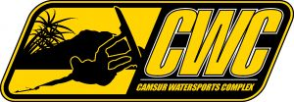
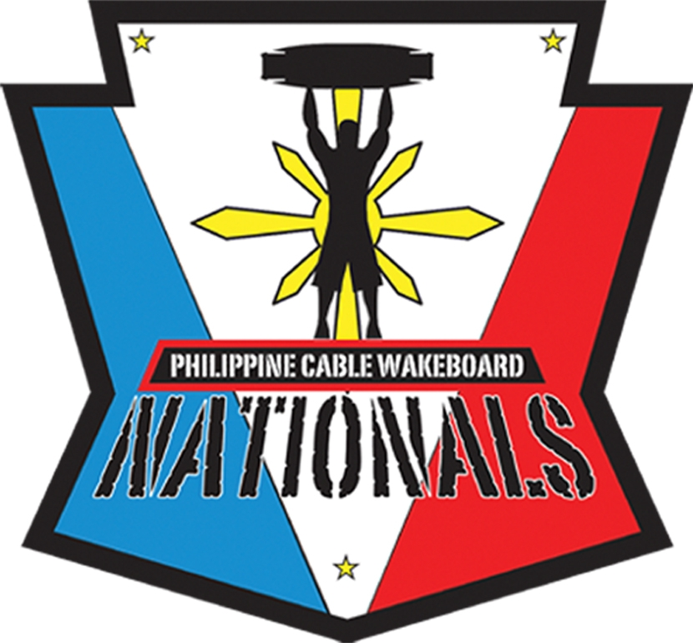

4th Philippine Cable Wakeboard Nationals
CWC RAIL PARK CONTEST REGISTRATION FORM

Athlete Name: |  |  |  |  |  |  |  |  |  | Male/Female
Address:
City: |  |  |  | State: |  |  |  |  | Postal Code:
Phone: |  |  |  |  | Country:
Email: |  |  |  |  |  | Age: |  |  | Date of Birth:
.

All Registration Forms should be sent by email or fax to CamSur Watersports Complex at philcablewakeboardnationals@yahoo.com or +63(2) 716-9950. Your registration confirmation will be sent via email. Print and present your confirmation during check-in

Entry fee the Winch Park Contest is Php 200.00.

Division (Please Circle or Highlight)

Pro Men Wakeboard Amateur Men Wakeboard
Open Wakeskate Amateur Women

Payment Type (Please Circle or Highlight)
VISA MasterCard AM Express Cash Onsite (late fee applies)
Card #____________________________________________________ Exp _______
Security Code (last 3 digits at back of card or 4 in front for Amex) ________________
Name on Card __________________________________________________________
Billing Address _________________________________________________________

